**7) How VPC peering helps to communicate between 2 VM instance in different networks ?**

Step 1 : Create a vpc network ‘network-a’ with two subnets.

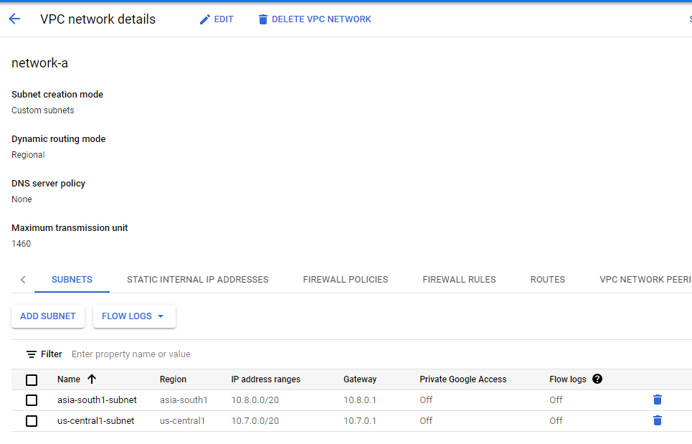

Step 2 : Assign firewall rules to the created network-a

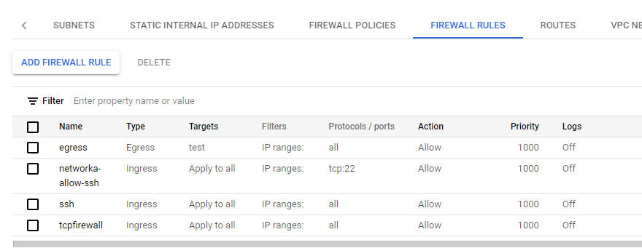

Step 3 : Create VM instance for default network with Networking field as follows

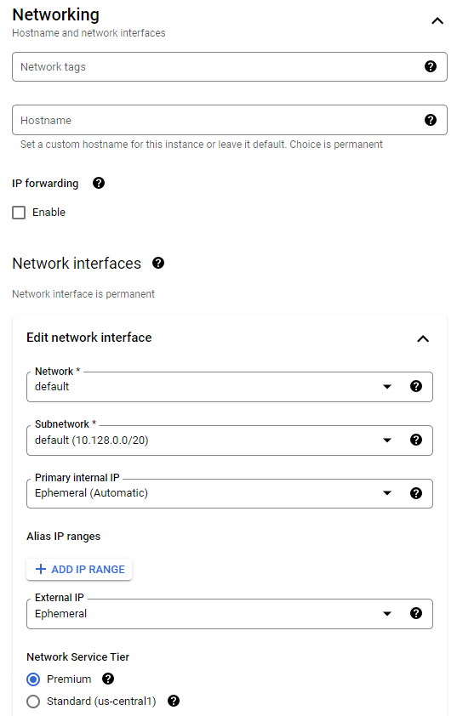

Step 4 : Create VM instance for network-a with Networking field as follows

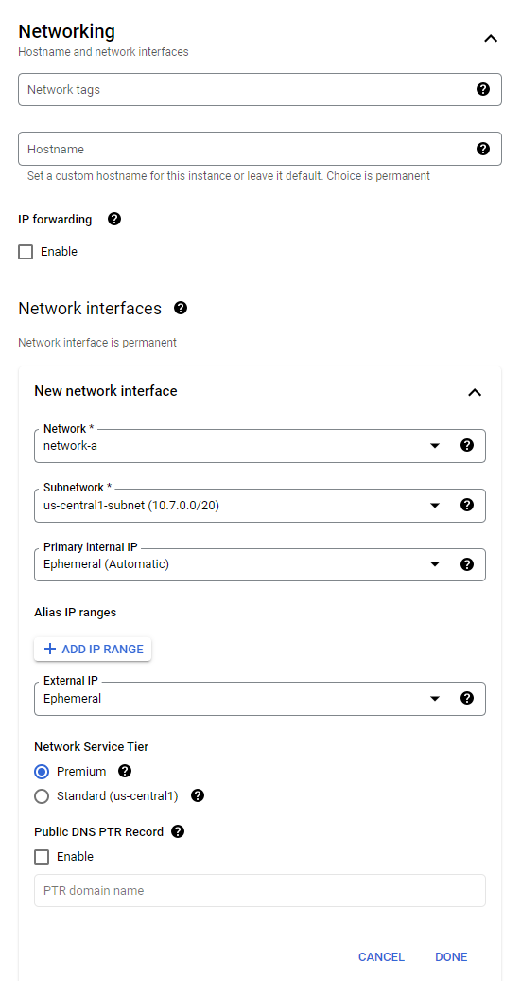

Step 5 : VM instances created for both default network and network-a

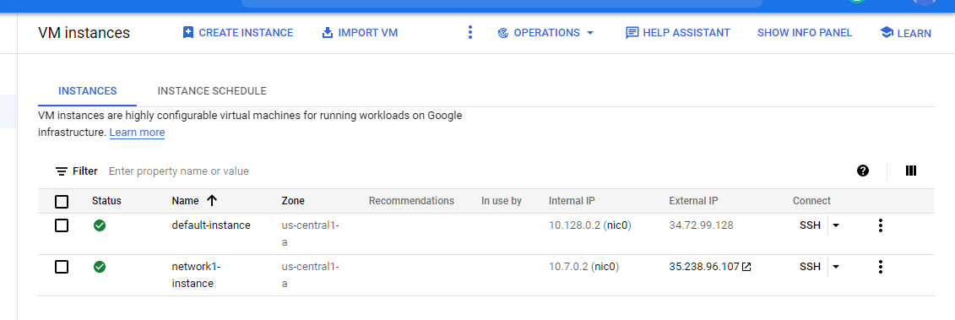

Step 6 : Try to connect these two networks by clicking on SSH and ping.

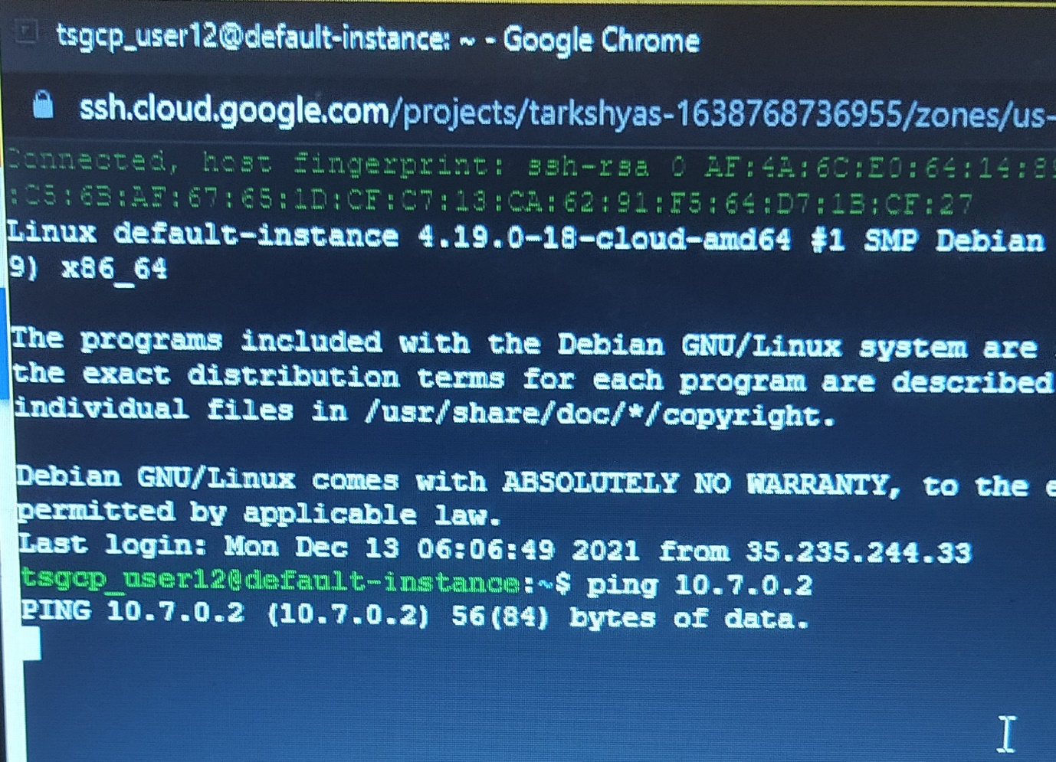

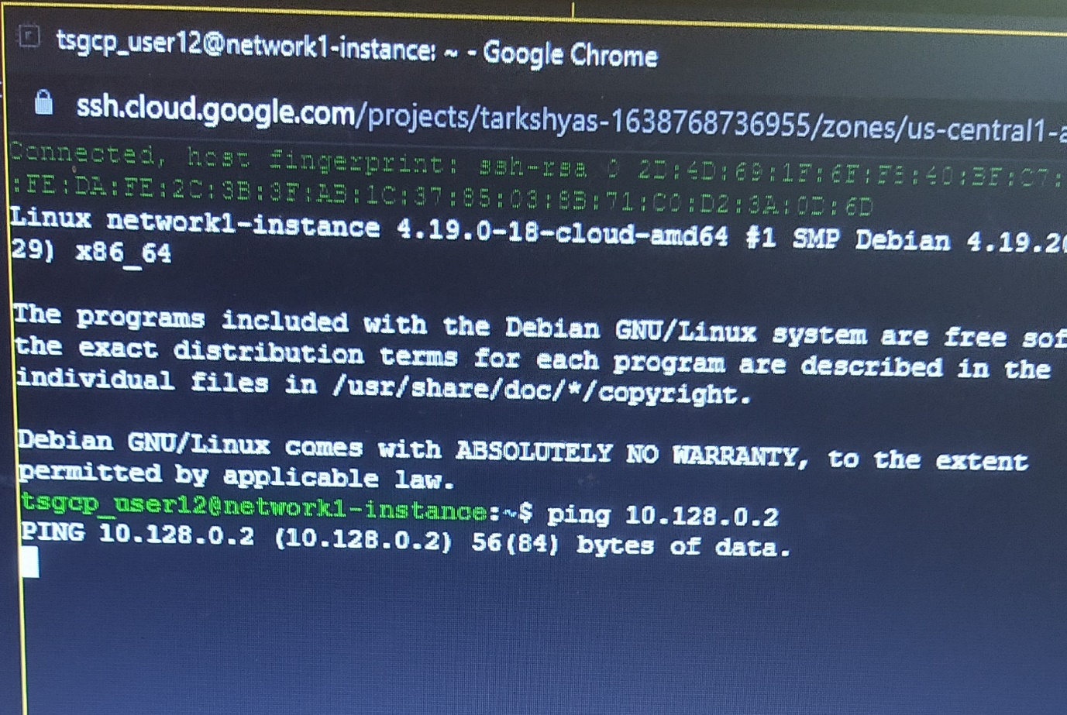

Ping doesn’t happens and so the connection fails. Inorder to establish connection, we need to create VPC peering.

Step 7 : Create VPC peering connection between default network and network-a as follows

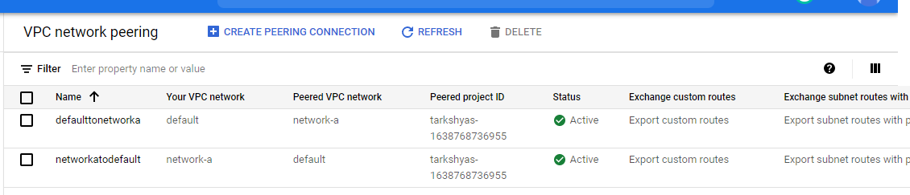

Step 8 : Now try to ping both networks.

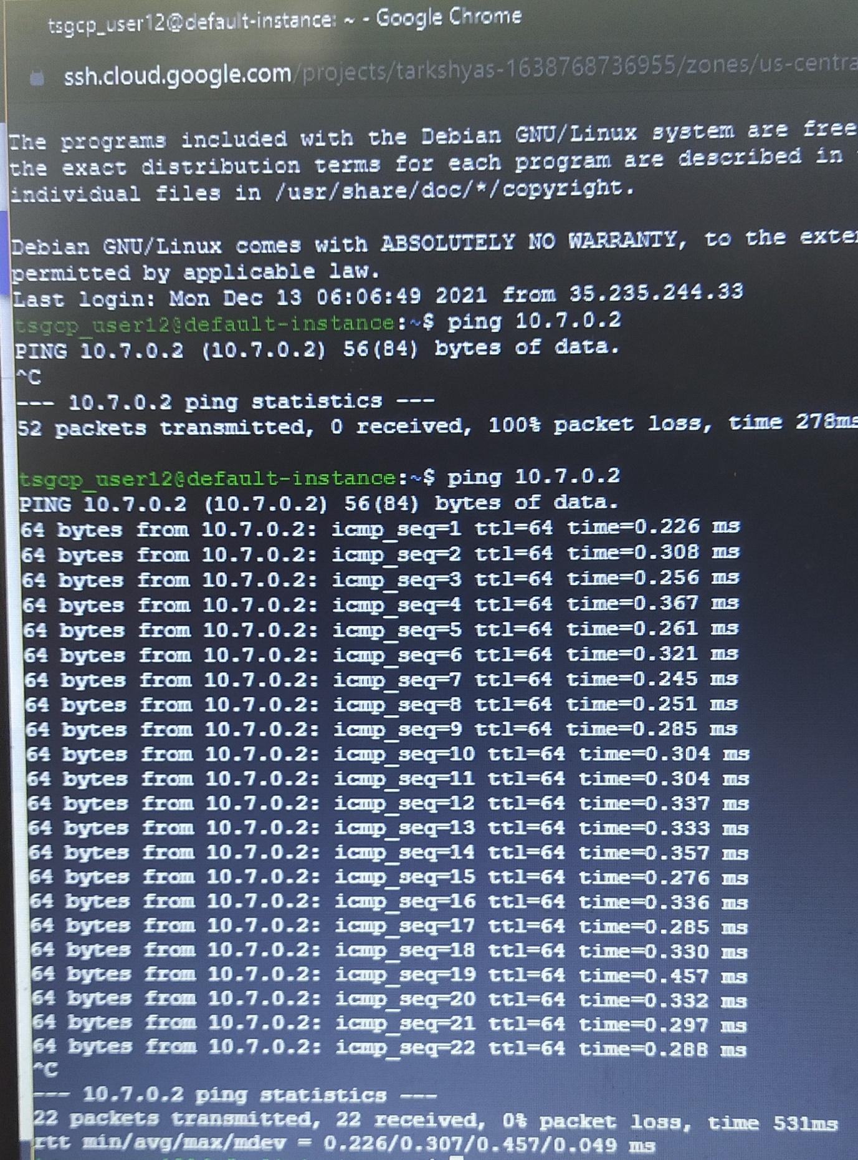

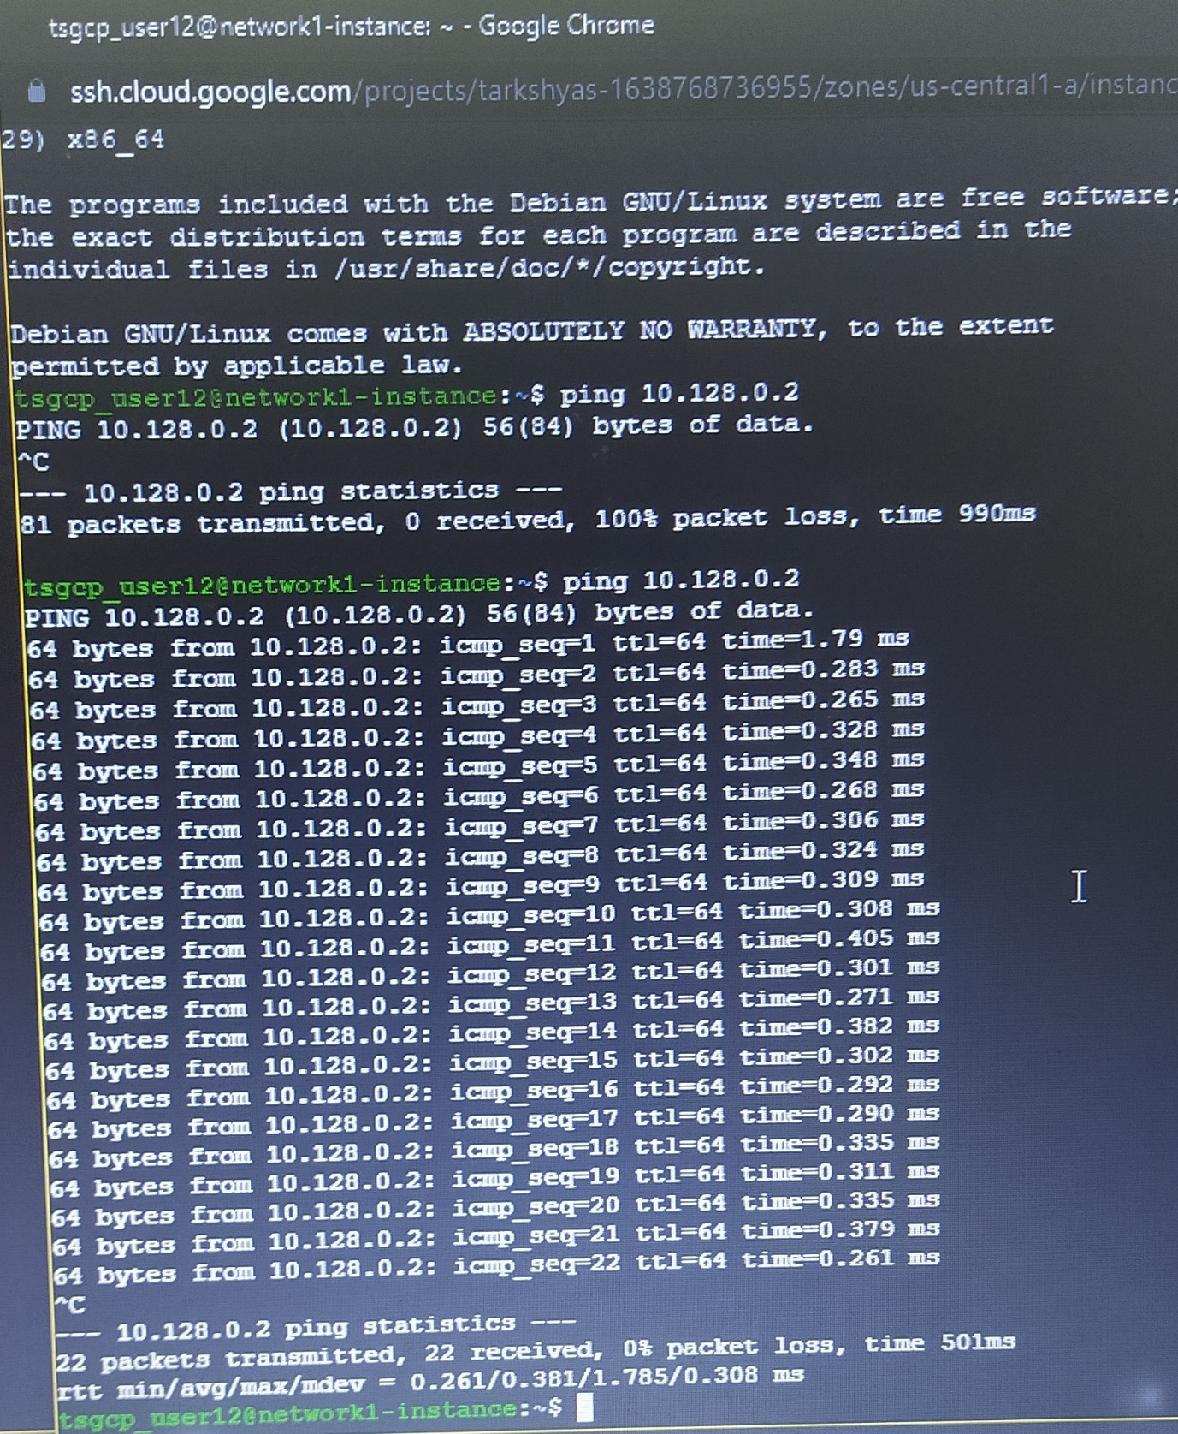

Connection established successfully.